AMRUTA INSTITUTE OF ENGINEERING AND MANAGEMENT SCIENCES – POLYTECHNIC
Course: Database System Concepts and PL/SQL
Course Code: 20CS34P
Week 10

The SQL comparison operators allow you to test if two expressions are the same. The following table illustrates the comparison operators in SQL:
Comparison Operator | Description
= | Equal
<> | Not Equal
!= | Not Equal
> | Greater Than
>= | Greater Than or Equal
< | Less Than
<= | Less Than or Equal
IN ( ) | Matches a value in a list
NOT | Negates a condition
BETWEEN | Within a range (inclusive)
IS NULL | NULL value
IS NOT NULL | Non-NULL value
LIKE | Pattern matching with % and _
EXISTS | Condition is met if subquery returns at least one row

Equality Operator
In SQL, you can use the = operator to test for equality in a query.
In this example, we have a table called suppliers with the following data:
supplier_id | supplier_name | city | state
100 | Microsoft | Redmond | Washington
200 | Google | Mountain View | California
300 | Oracle | Redwood City | California
400 | Kimberly-Clark | Irving | Texas
500 | Tyson Foods | Springdale | Arkansas
600 | SC Johnson | Racine | Wisconsin
700 | Dole Food Company | Westlake Village | California
800 | Flowers Foods | Thomasville | Georgia
900 | Electronic Arts | Redwood City | California
Enter the following SQL statement:
SELECT *
FROM suppliers
WHERE supplier_name = 'Microsoft';
There will be 1 record selected. These are the results that you should see:
supplier_id | supplier_name | City | state
100 | Microsoft | Redmond | Washington

Inequality Operator
In SQL, there are two ways to test for inequality in a query. You can use either the <> or != operator. Both will return the same results.
Let's use the same suppliers table as the previous example.
supplier_id | supplier_name | City | state
100 | Microsoft | Redmond | Washington
200 | Google | Mountain View | California
300 | Oracle | Redwood City | California
400 | Kimberly-Clark | Irving | Texas
500 | Tyson Foods | Springdale | Arkansas
600 | SC Johnson | Racine | Wisconsin
700 | Dole Food Company | Westlake Village | California
800 | Flowers Foods | Thomasville | Georgia
900 | Electronic Arts | Redwood City | California
Enter the following SQL statement to test for inequality using the <> operator:
SELECT *
FROM suppliers
WHERE supplier_name <> 'Microsoft';
OR enter this next SQL statement to use the != operator:
SELECT *
FROM suppliers
WHERE supplier_name != 'Microsoft';
There will be 8 records selected. These are the results you should see with either one of the SQL statements:
supplier_id | supplier_name | city | state
200 | Google | Mountain View | California
300 | Oracle | Redwood City | California
400 | Kimberly-Clark | Irving | Texas
500 | Tyson Foods | Springdale | Arkansas
600 | SC Johnson | Racine | Wisconsin
700 | Dole Food Company | Westlake Village | California
800 | Flowers Foods | Thomasville | Georgia
900 | Electronic Arts | Redwood City | California

Greater Than Operator
You can use the > operator in SQL to test for an expression greater than.
In this example, we have a table called customers with the following data:
customer_id | last_name | first_name | favorite_website
4000 | Jackson | Joe | techonthenet.com
5000 | Smith | Jane | digminecraft.com
6000 | Ferguson | Samantha | bigactivities.com
7000 | Reynolds | Allen | checkyourmath.com
8000 | Anderson | Paige | NULL
9000 | Johnson | Derek | techonthenet.com
Enter the following SQL statement:
SELECT *
FROM customers
WHERE customer_id > 6000;
There will be 3 records selected. These are the results that you should see:
customer_id | last_name | first_name | favorite_website
7000 | Reynolds | Allen | checkyourmath.com
8000 | Anderson | Paige | NULL
9000 | Johnson | Derek | techonthenet.com

Greater Than or Equal Operator
In SQL, you can use the >= operator to test for an expression greater than or equal to.
Let's use the same customers table as the previous example.
customer_id | last_name | first_name | favorite_website
4000 | Jackson | Joe | techonthenet.com
5000 | Smith | Jane | digminecraft.com
6000 | Ferguson | Samantha | bigactivities.com
7000 | Reynolds | Allen | checkyourmath.com
8000 | Anderson | Paige | NULL
9000 | Johnson | Derek | techonthenet.com
Enter the following SQL statement:
SELECT *
FROM customers
WHERE customer_id >= 6000;
There will be 4 records selected. These are the results that you should see:
customer_id | last_name | first_name | favorite_website
6000 | Ferguson | Samantha | bigactivities.com
7000 | Reynolds | Allen | checkyourmath.com
8000 | Anderson | Paige | NULL
9000 | Johnson | Derek | techonthenet.com

Less Than Operator
You can use the < operator in SQL to test for an expression less than.
In this example, we have a table called products with the following data:
product_id | product_name | category_id
1 | Pear | 50
2 | Banana | 50
3 | Orange | 50
4 | Apple | 50
5 | Bread | 75
6 | Sliced Ham | 25
7 | Kleenex | NULL

Enter the following SQL statement:
SELECT *
FROM products
WHERE product_id < 5;
There will be 4 records selected. These are the results that you should see:
product_id | product_name | category_id
1 | Pear | 50
2 | Banana | 50
3 | Orange | 50
4 | Apple | 50

Less Than or Equal Operator
In SQL, you can use the <= operator to test for an expression less than or equal to.
Let's use the same products table as the previous example.
product_id | product_name | category_id
1 | Pear | 50
2 | Banana | 50
3 | Orange | 50
4 | Apple | 50
5 | Bread | 75
6 | Sliced Ham | 25
7 | Kleenex | NULL
Enter the following SQL statement:
SELECT *
FROM products
WHERE product_id <= 5;
There will be 5 records selected. These are the results that you should see:
product_id | product_name | category_id
1 | Pear | 50
2 | Banana | 50
3 | Orange | 50
4 | Apple | 50
5 | Bread | 75

IN operator
The SQL IN condition (sometimes called the IN operator) allows you to easily test if an expression matches any value in a list of values. It is used to help reduce the need for multiple OR conditions in a SELECT, INSERT, UPDATE, or DELETE statement.
The syntax for the IN condition in SQL is:
expression IN (value1, value2, .... value_n);
OR
expression IN (subquery);
where expression is a value to test and
value1, value2 ..., value_n are the values to test against expression. If any of these values matches expression, then the IN condition will evaluate to true.
Subquery is a SELECT statement whose result set will be tested against expression. If any of these values matches expression, then the IN condition will evaluate to true.
In this example, we have a table called suppliers with the following data:
supplier_id | supplier_name | city | state
100 | Microsoft | Redmond | Washington
200 | Google | Mountain View | California
300 | Oracle | Redwood City | California
400 | Kimberly-Clark | Irving | Texas
500 | Tyson Foods | Springdale | Arkansas
600 | SC Johnson | Racine | Wisconsin
700 | Dole Food Company | Westlake Village | California
800 | Flowers Foods | Thomasville | Georgia
900 | Electronic Arts | Redwood City | California
Enter the following SQL statement:
SELECT *
FROM suppliers
WHERE supplier_name IN ('Microsoft', 'Oracle', 'Flowers Foods');
There will be 3 records selected. These are the results that you should see:
supplier_id | supplier_name | city | state
100 | Microsoft | Redmond | Washington
300 | Oracle | Redwood City | California
800 | Flowers Foods | Thomasville | Georgia

NOT Operator
The SQL NOT condition (sometimes called the NOT Operator) is used to negate a condition in the WHERE clause of a SELECT, INSERT, UPDATE, or DELETE statement.
The syntax for the NOT condition in SQL is:
NOT condition

Where condition is the condition to negate. The opposite of the condition must be met for the record to be included in the result set.
In this example, we have a table called products with the following data:
product_id | product_name | category_id
1 | Pear | 50
2 | Banana | 50
3 | Orange | 50
4 | Apple | 50
5 | Bread | 75
6 | Sliced Ham | 25
7 | Kleenex | NULL
Enter the following SQL statement:
SELECT *
FROM products
WHERE product_name NOT IN ('Pear', 'Banana', 'Bread');
There will be 4 records selected. These are the results that you should see:
product_id | product_name | category_id
3 | Orange | 50
4 | Apple | 50
6 | Sliced Ham | 25
7 | Kleenex | NULL
This example would return all rows from the products table where the product_name is not Pear, Banana or Bread.
BETWEEN
The SQL BETWEEN condition allows you to easily test if an expression is within a range of values (inclusive). It can be used in a SELECT, INSERT, UPDATE, or DELETE statement.
The syntax for the BETWEEN condition in SQL is:
expression BETWEEN value1 AND value2;

where expression is a column or calculation.
value1 and value2 create an inclusive range that expression is compared to.
In this example, we have a table called suppliers with the following data:
supplier_id | supplier_name | city | state
100 | Microsoft | Redmond | Washington
200 | Google | Mountain View | California
300 | Oracle | Redwood City | California
400 | Kimberly-Clark | Irving | Texas
500 | Tyson Foods | Springdale | Arkansas
600 | SC Johnson | Racine | Wisconsin
700 | Dole Food Company | Westlake Village | California
800 | Flowers Foods | Thomasville | Georgia
900 | Electronic Arts | Redwood City | California
Enter the following SELECT statement:
SELECT *
FROM suppliers
WHERE supplier_id BETWEEN 300 AND 600;
There will be 4 records selected. These are the results that you should see:
supplier_id | supplier_name | city | state
300 | Oracle | Redwood City | California
400 | Kimberly-Clark | Irving | Texas
500 | Tyson Foods | Springdale | Arkansas
600 | SC Johnson | Racine | Wisconsin
This example would return all rows from the suppliers table where the supplier_id is between 300 and 600 (inclusive).
IS NULL
The IS NULL condition is used in SQL to test for a NULL value. It returns TRUE if a NULL value is found, otherwise it returns FALSE. It can be used in a SELECT, INSERT, UPDATE, or DELETE statement.
The syntax for the IS NULL condition in SQL is:
expression IS NULL
where expression is the expression to test for a NULL value.
In this example, we have a table called customers with the following data:
customer_id | last_name | first_name | favorite_website
4000 | Jackson | Joe | techonthenet.com
5000 | Smith | Jane | digminecraft.com
6000 | Ferguson | Samantha | bigactivities.com
7000 | Reynolds | Allen | checkyourmath.com
8000 | Anderson | Paige | NULL
9000 | Johnson | Derek | techonthenet.com

Enter the following SQL statement:
SELECT *
FROM customers
WHERE favorite_website IS NULL;
There will be 1 record selected.
customer_id | last_name | first_name | favorite_website
8000 | Anderson | Paige | NULL
This example will return all records from the customers table where the favorite_website contains a NULL value.
IS NOT NULL
The IS NOT NULL condition is used in SQL to test for a non-NULL value. It returns TRUE if a non-NULL value is found, otherwise it returns FALSE. It can be used in a SELECT, INSERT, UPDATE, or DELETE statement.
The syntax for the IS NOT NULL condition in SQL is:
expression IS NOT NULL
where the expression is to test for a NOT NULL value.
In this example, we have a table called products with the following data:
product_id | product_name | category_id
1 | Pear | 50
2 | Banana | 50
3 | Orange | 50
4 | Apple | 50
5 | Bread | 75
6 | Sliced Ham | 25
7 | Kleenex | NULL
Enter the following SQL statement:
SELECT *
FROM products
WHERE category_id IS NOT NULL;
There will be 6 records selected. These are the results that you should see:
product_id | product_name | category_id
1 | Pear | 50
2 | Banana | 50
3 | Orange | 50
4 | Apple | 50
5 | Bread | 75
6 | Sliced Ham | 25
This example will return all records from the products table where the customer_id does not contain a NULL value.
LIKE
The SQL LIKE condition allows you to use wildcards to perform pattern matching in a query. The LIKE condition is used in the WHERE clause of a SELECT, INSERT, UPDATE, or DELETE statement.
The syntax for the LIKE condition in SQL is:
expression LIKE pattern

where expression is a character expression such as a column or field and
pattern is a character expression that contains pattern matching. The wildcards that you can choose from are:
Wildcard | Explanation
% | Allows you to match any string of any length (including zero length)
_ | Allows you to match on a single character
In this example, we have a table called customers with the following data:
customer_id | last_name | first_name | favorite_website
4000 | Jackson | Joe | techonthenet.com
5000 | Smith | Jane | digminecraft.com
6000 | Ferguson | Samantha | bigactivities.com
7000 | Reynolds | Allen | checkyourmath.com
8000 | Anderson | Paige | NULL
9000 | Johnson | Derek | techonthenet.com
Enter the following SQL statement:
SELECT *
FROM customers
WHERE last_name LIKE 'J%'
ORDER BY last_name;
There will be 2 records selected. These are the results that you should see:
customer_id | last_name | first_name | favorite_website
4000 | Jackson | Joe | techonthenet.com
9000 | Johnson | Derek | techonthenet.com
This example returns the records in the customers table where the last_name starts with 'J'. As you can see, the records for the last names Jackson and Johnson have been returned.

Using Multiple % Wildcards in the LIKE Condition

You can also using the % wildcard multiple times with the LIKE condition.
Using the same customers table with the following data:
customer_id | last_name | first_name | favorite_website
4000 | Jackson | Joe | techonthenet.com
5000 | Smith | Jane | digminecraft.com
6000 | Ferguson | Samantha | bigactivities.com
7000 | Reynolds | Allen | checkyourmath.com
8000 | Anderson | Paige | NULL
9000 | Johnson | Derek | techonthenet.com

Let's try to find all last_name values from the customers table where the last_name contains the letter 'e'. Enter the following SQL statement:
SELECT last_name
FROM customers
WHERE last_name LIKE '%e%'
ORDER BY last_name;
There will be 3 records selected. These are the results that you should see:
last_name
Anderson
Ferguson
Reynolds
In this example, the last names Anderson, Ferguson and Reynolds contain the letter 'e'.
Example - Using _ Wildcard in the LIKE Condition
_ wildcard is looking for exactly one character, unlike the % wildcard.
Using the categories table with the following data:
category_id | category_name
25 | Deli
50 | Produce
75 | Bakery
100 | General Merchandise
125 | Technology
Let's try to find all records from the categories table where the category_id is 2-digits long and ends with '5'. Enter the following SQL statement:
SELECT *
FROM categories
WHERE category_id LIKE '_5';
There will be 2 records selected. These are the results that you should see:
category_id | category_name
25 | Deli
75 | Bakery
In this example, there are 2 records that will pattern match - the category_id values 25 and 75. Notice that the category_id of 125 was not selected because, the _ wilcard matches only on a single character.

Using Multiple _ Wildcards in the LIKE Condition
If you wanted to match on a 3-digit value that ended with '5', you would need to use the _ wildcard two times. You could modify your query as follows:
SELECT *
FROM categories
WHERE category_id LIKE '__5';
Now you will return the category_id value of 125:
category_id | category_name
125 | Technology

EXISTS
The SQL EXISTS condition is used in combination with a subquery and is considered to be met, if the subquery returns at least one row. It can be used in a SELECT, INSERT, UPDATE, or DELETE statement.
The syntax for the EXISTS condition in SQL is:

WHERE EXISTS ( subquery );
Where subquery is a SELECT statement. If the subquery returns at least one record in its result set, the EXISTS clause will evaluate to true and the EXISTS condition will be met. If the subquery does not return any records, the EXISTS clause will evaluate to false and the EXISTS condition will not be met.
In this example, we have a customers table with the following data:
customer_id | last_name | first_name | favorite_website
4000 | Jackson | Joe | techonthenet.com
5000 | Smith | Jane | digminecraft.com
6000 | Ferguson | Samantha | bigactivities.com
7000 | Reynolds | Allen | checkyourmath.com
8000 | Anderson | Paige | NULL
9000 | Johnson | Derek | techonthenet.com
And a table called orders with the following data:
order_id | customer_id | order_date
1 | 7000 | 2016/04/18
2 | 5000 | 2016/04/18
3 | 8000 | 2016/04/19
4 | 4000 | 2016/04/20

Now let's find all of the records from the customers table where there is at least one record in the orders table with the same customer_id. Enter the following SELECT statement:
SELECT *
FROM customers
WHERE EXISTS
(SELECT *
FROM orders
WHERE customers.customer_id = orders.customer_id);
There will be 4 records selected. These are the results that you should see:
customer_id | last_name | first_name | favorite_website
4000 | Jackson | Joe | techonthenet.com
5000 | Smith | Jane | digminecraft.com
7000 | Reynolds | Allen | checkyourmath.com
8000 | Anderson | Paige | NULL

In this example, there are 4 records in the customers where the customer_id value appears in the orders table.

SubQueries
- A Subquery or Nested query is a query within another SQL query and embedded within the WHERE clause. A subquery is a query within a query
- A subquery is used to return data that will be used in the main query as a condition to further restrict the data to be retrieved.
- (3)Subqueries can be used with the SELECT, INSERT, UPDATE, and DELETE statements along with the operators like =, <, >, >=, <=, IN, BETWEEN etc.
- We need to put sub queries in parenthesis always
- We need to place subqueries on the right side of the comparison operator
- Use single row operator with single row subqueries and multiple row operator with multiple row subqueries
General Syntax
SELECT col1, col2
FROM table1
WHERE col1 OPERATOR
(SELECT col1
FROM table2
[WHERE])

Single Row Subquery
- It returns only one row of results and uses a single row operator (most common is the equal operator (=)). The other operators are > ,< ,>= ,=<
- Single row subqueries can select data from the same table or from another table
SELECT ENAME
FROM EMP
WHERE SAL = (SELECT MIN(SAL) FROM EMP);
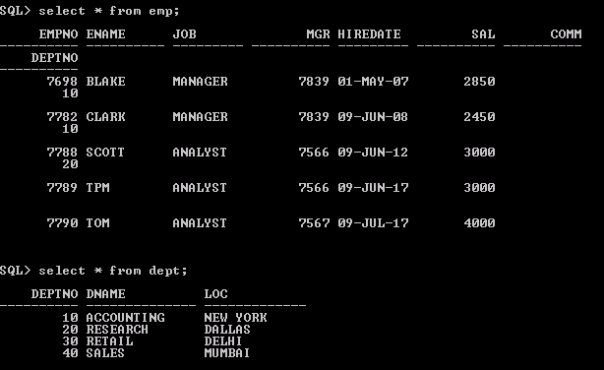
SELECT ENAME
FROM EMP
WHERE DEPTNO = (SELECT DEPTNO FROM DEPT WHERE DNAME = 'RESEARCH');
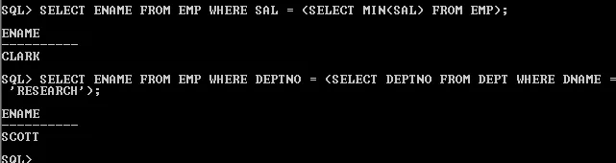

Multiple Row Subquery
- It returns several rows of results from the subquery, uses the IN operator.
- The other operator which are used is any and all
SELECT ENAME, DEPTNO FROM EMP
WHERE DEPTNO IN (SELECT DEPTNO FROM DEPT WHERE DNAME LIKE 'R%');
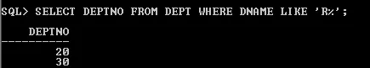

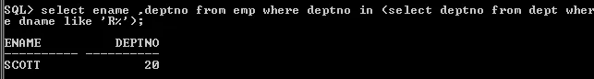

Correlated Subquery
- A correlated SQL subquery is just a subquery that is executed many times—once for each record (row) returned by the outer (main) query.
- In other words, the outer query returns a table with multiple rows; the inner query then runs once for each of those rows.
- If your outer query returns 10 rows, then the inner query will run 10 times. And if your outer query returns 100 rows, the inner query will run 100 times.
- So a correlated subquery (also known as a synchronized subquery) is a subquery (a query nested inside another query) that uses values from the outer query.
- Because the subquery may be evaluated once for each row processed by the outer query, it can be slow.
Here is an example for a typical correlated subquery. In this example, the objective is to find all employees whose salary is above average for their department.
SELECT employee_number, name
FROM employees emp
WHERE salary > ( SELECT AVG(salary)
FROM employees
WHERE department = emp.department );
In the above query the outer query is
SELECT employee_number, name
FROM employees emp
WHERE salary > ...
and the inner query (the correlated subquery) is
SELECT AVG(salary)
FROM employees
WHERE department = emp.department
In the above nested query the inner query has to be re-executed for each employee

Correlated subquery with EXISTS operator
- The EXISTS operator is used to test for the existence of any record in a subquery.
- The EXISTS operator returns TRUE if the subquery returns one or more records.

EXISTS Syntax
SELECT column_name(s)
FROM table_name
WHERE EXISTS (SELECT column_name
FROM table_name
WHERE condition);

The EXISTS operator is used to check the existence of a result of a subquery. Using EXISTS the following query display the employee_id, manager_id, first_name and last_name of those employees who manage other employees.
SELECT employee_id, manager_id, first_name, last_name
FROM employees a
WHERE EXISTS (SELECT employee_id
FROM employees b
WHERE b.manager_id = a.employee_id)

Example 2: we have a customers table with the following data:
customer_id | last_name | first_name | favorite_website
4000 | Jackson | Joe | techonthenet.com
5000 | Smith | Jane | digminecraft.com
6000 | Ferguson | Samantha | bigactivities.com
7000 | Reynolds | Allen | checkyourmath.com
8000 | Anderson | Paige | NULL
9000 | Johnson | Derek | techonthenet.com
And a table called orders with the following data:
order_id | customer_id | order_date
1 | 7000 | 2016/04/18
2 | 5000 | 2016/04/18
3 | 8000 | 2016/04/19
4 | 4000 | 2016/04/20

Now let's find all of the records from the customers table where there is at least one record in the orders table with the same customer_id. Enter the following SELECT statement:
SELECT *
FROM customers
WHERE EXISTS
(SELECT *
FROM orders
WHERE customers.customer_id = orders.customer_id);
There will be 4 records selected. These are the results that you should see:
customer_id | last_name | first_name | favorite_website
4000 | Jackson | Joe | techonthenet.com
5000 | Smith | Jane | digminecraft.com
7000 | Reynolds | Allen | checkyourmath.com
8000 | Anderson | Paige | NULL

In this example, there are 4 records in the customers where the customer_id value appears in the orders table.

Correlated subquery with NOT EXISTS operator
- NOT EXISTS is logically opposite of EXISTS operator.
- NOT EXISTS is used when we need to check if rows do not exist in the results returned by a subquery.

NOT EXISTS Syntax
SELECT column_name(s)
FROM table_name
WHERE NOT EXISTS (SELECT column_name
FROM table_name
WHERE condition);
Using NOT EXISTS the following query display the employee_id, manager_id, first_name and last_name of those employees who have no manager status. This query is opposite to the previous one.

SELECT employee_id, manager_id, first_name, last_name
FROM employees a
WHERE NOT EXISTS (SELECT employee_id
FROM employees b
WHERE b.manager_id = a.employee_id);

For example, the following query returns all employees who have no dependents:
SELECT employee_id, first_name, last_name
FROM employees e
WHERE NOT EXISTS( SELECT *
FROM dependents d
WHERE d.employee_id = e.employee_id)
ORDER BY first_name , last_name;
The following picture shows the output:
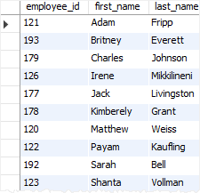
Example 3:
In this example, we have a table called customers with the following data:
customer_id | last_name | first_name | favorite_website
4000 | Jackson | Joe | techonthenet.com
5000 | Smith | Jane | digminecraft.com
6000 | Ferguson | Samantha | bigactivities.com
7000 | Reynolds | Allen | checkyourmath.com
8000 | Anderson | Paige | NULL
9000 | Johnson | Derek | techonthenet.com

And a table called orders with the following data:
order_id | customer_id | order_date
1 | 7000 | 2016/04/18
2 | 5000 | 2016/04/18
3 | 8000 | 2016/04/19
4 | 4000 | 2016/04/20
5 | NULL | 2016/05/01
Enter the following SQL statement:
SELECT *
FROM customers
WHERE NOT EXISTS
(SELECT *
FROM orders
WHERE customers.customer_id = orders.customer_id);
There will be 2 records selected.
customer_id | last_name | first_name | favorite_website
6000 | Ferguson | Samantha | bigactivities.com
9000 | Johnson | Derek | techonthenet.com

This example would return all records from the customers table where there are no records in the orders table for the given customer_id.

Correlated subquery with ANY operator
The ANY operator is used to compare a value to a list of values or result set returned by a subquery. The following illustrates the syntax of the ANY operator when it is used with a list or subquery:
SELECT column_name(s)
FROM table_name
WHERE column_name operator ANY (SELECT column_name
FROM table_name
WHERE condition);
In this syntax:
- The ANY operator must be preceded by a comparison operator such as =, !=, >, >=,<, <=.
- The list or subquery must be surrounded by the parentheses.
- ANY means that the condition will be true if the operation is true for any of the values in the range.
For example,consider the tables example1 and example2,
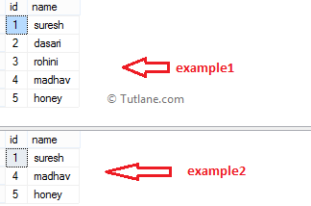
SELECT id,name
FROM example1
WHERE id = ANY(SELECT Id FROM example2)
When we execute the above SQL query, we will get a SQL any operator result like as shown below.

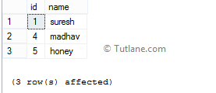

SELECT id,name
FROM example1
id >= ANY(SELECT Id FROM example2)
When we execute the above query, we will get the result as shown below.

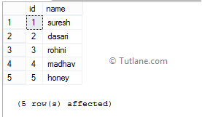
For example, the following statement returns all products whose list price is greater than any list price of products in the category 1:
SELECT product_name, list_price
FROM products
WHERE list_price > ANY( SELECT list_price
FROM products
WHERE category_id = 1 )

Correlated subquery with ALL operator
ALL operator is used to compare a value to a list of values or result set returned by a subquery.
The following shows the syntax of the ALL operator used with a list or a subquery:
SELECT column_name(s)
FROM table_name
WHERE column_name operator ALL (SELECT column_name
FROM table_name
WHERE condition);
In this syntax:
- The ALL operator must be preceded by an comparison operator such as =, != >,>=, <, <= and followed by a subquery.
- The list or subquery must be surrounded by the parentheses.
- ALL means that the condition will be true only if the operation is true for all values in the range.
Consider the following Products Table and OrderDetails Table,
Products Table
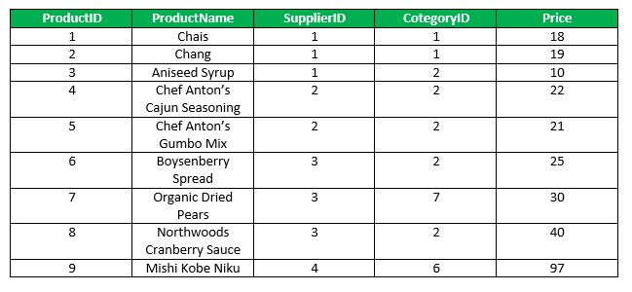
OrderDetails Table
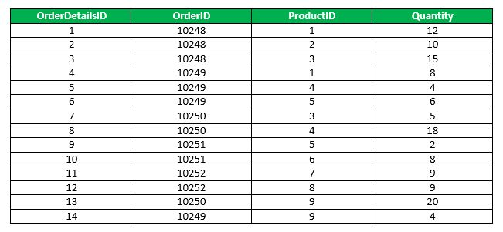
The followinq sql statement finds the name of the product if all the records in the OrderDetails has Quantity either equal to 6 or 2.
SELECT ProductName
FROM Products
WHERE ProductID = ALL (SELECT ProductId
FROM OrderDetails
WHERE Quantity = 6 OR Quantity = 2);

Output:
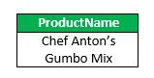

Another example is the following query, which returns the names of employees whose salary is greater than the salary of all the employees in department 5:
SELECT Lname, Fname
FROM EMPLOYEE
WHERE Salary > ALL ( SELECT Salary
FROM EMPLOYEE
WHERE Dno=5 );
Example 2: the following statement returns all products whose list price is greater than all list price of products in the category 1:
SELECT product_name,list_price
FROM products
WHERE list_price > ALL ( SELECT list_price
FROM products
WHERE category_id = 1 )
ORDER BY product_name;

Correlated subquery with SOME operator
- In SQL, the SOME operator is used to compare a value with a single column set of values returned by the subquery.
- The SOME operator in SQL must match at least one value in a subquery and that value must be preceded by comparison operators.
- Generally we will use this SOME operator in WHERE clause to check whether the required column values are matching with the set of values returned by subquery or not.

Syntax of SQL SOME Operator
SELECT column1,column2
FROM tablename
WHERE column1 = SOME(SELECT column1
FROM tablename
WHERE column1 ='somevalue')
If you observe above SQL SOME operator syntax, we will get values only when column1 values matches with column1 data returned by subquery otherwise it will not return any data.
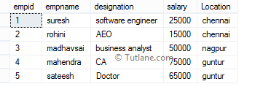
The following sql statement will return employee details whose salary column values match with the data returned by the subquery.

SELECT *
FROM EmployeeDetails
WHERE salary = SOME(SELECT salary
FROM EmployeeDetails
WHERE salary >25000)
When we execute above sql query, we will get the result will be like as shown below.

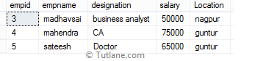
The following sql statement will return employee details whose salary column value matches with at least one value with the data returned by subquery and that value must be preceded by comparison operators.

SELECT *
FROM EmployeeDetails
WHERE salary > SOME(SELECT salary
FROM EmployeeDetails
WHERE salary >25000)
When we execute the above query, we will get the result as shown below.

